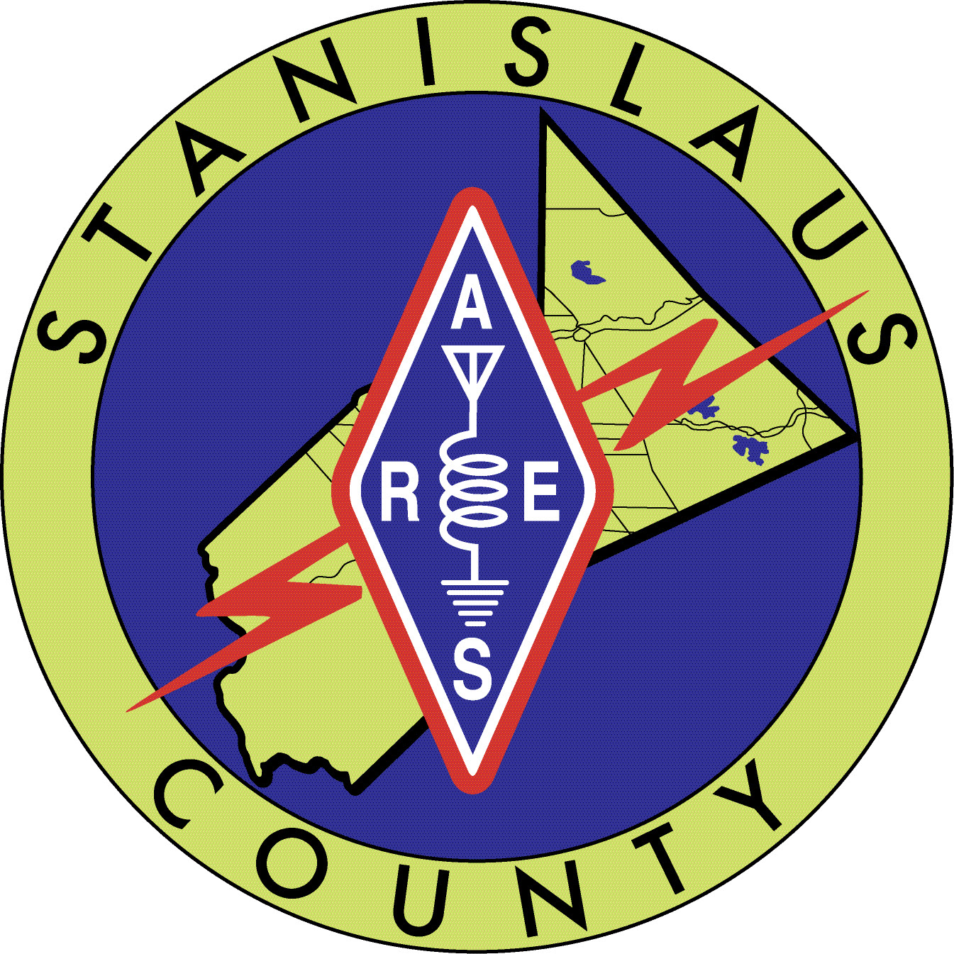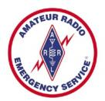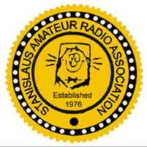

2024 ARES and SARA Club Meetings and Events Schedule as of
May 29, 2024

June
Saturday 8th (rescheduled from March) Snelling Road Race Henderson Park Snelling, CA 7a-4p (depending on assignment) need 10 operators.

Sunday 9th Regalado Road Race 7a-12p Burchell Nursery 1200 California 120 (Highway 120/Wamble Road) Oakdale, CA 95361, need 8 operators.

Saturday 15^{h} ARES Meeting 10a-12p

Tuesday 18th SARA Meeting 7p-8p

Saturday through Sunday (22-23) Field Day www.arrl.org/field-day

July
Saturday 13th ARES Meeting 10a-12p

Tuesday 16th SARA Meeting 7p-8p

August
Saturday 3rd Warnerville Time Trial 7a-12pm Willms Road East of Oakdale, near Knights Ferry need 5 operators.

Saturday 10th ARES Meeting 10a-12p

Tuesday 20th SARA Meeting 7p-8p

September
Saturday 7th ARES Meeting 9a-1p (adjusted hours for the planned Simulated Emergency Test {SET})

Saturday September 14th Gradeada Park Modesto, CA Walk to End Alzheimers 8a-12p. 5 operators.

Tuesday 17th SARA Meeting 7p-8p

October
Saturday 12th ARES Meeting 10-12p

Tuesday 15th SARA Meeting 7p-8p

Thursday 17th California Shakeout Drill TBD

Friday-Sunday (18, 19, 20) Pacificon San Ramon Marriot
November
Saturday 9th ARES Meeting 10a-12p

Tuesday 19th SARA Meeting 7p-8p

December
Saturday 14th ARES meeting 10a-12p

Tuesday 17th SARA meeting 7p-8p

